Static analysis

What is Static analysis
# Source: AI Source: Provided by: [Data Path: Persons Table -> ID Column: 1, Name_En Column: Motasem Essam] -> From: [ChatGPT] on [8/23/2025]
Static analysis is a method of examining software without executing it.
It means analyzing the source code, bytecode, or even documentation to detect issues before running the program.

Key points about static analysis:
# Source: AI Source: Provided by: [Data Path: Persons Table -> ID Column: 1, Name_En Column: Motasem Essam] -> From: [ChatGPT] on [8/23/2025]
- ✅ No execution → it checks the code itself, not how it behaves when running.
- ✅ Automated tools can scan code for potential bugs, security vulnerabilities, coding standard violations, or complexity issues.
- ✅ Helps in early defect detection → cheaper to fix than after testing or deployment.

Static Analysis tools

🔹What is Static Analysis Tools
# Source: AI Source: Provided by: [Data Path: Persons Table -> ID Column: 1, Name_En Column: Motasem Essam] -> From: [ChatGPT] on [8/23/2025]
Static Analysis Tools are software programs that automatically check code or documentation without executing it, to detect:
- Bugs
- Security vulnerabilities
- Style/coding standard violations
- Ambiguity or incompleteness in requirements/tests
They save time by finding problems early, before testing or deployment.

🔹 How They Work
# Source: AI Source: Provided by: [Data Path: Persons Table -> ID Column: 1, Name_En Column: Motasem Essam] -> From: [ChatGPT] on [8/23/2025]
- Parse the artifact (source code, requirements, test scripts, API docs).
- Apply rules or patterns (e.g., "flag ambiguous words", "variables must be camelCase", "no buffer overflows").
- Report findings (warnings, errors, severity levels).
- Suggest fixes (some tools even auto-correct).

🔹 Types of Static Analysis Tools
# Source: AI Source: Provided by: [Data Path: Persons Table -> ID Column: 1, Name_En Column: Motasem Essam] -> From: [ChatGPT] on [8/23/2025]
- Code Quality & Style Checkers
  - ESLint (JavaScript/TypeScript)
  - Pylint (Python)
  - Checkstyle (Java)
- Security-Focused Tools
  - Bandit (Python security)
  - Fortify (enterprise security)
  - SonarQube (bugs + vulnerabilities)
- Safety-Critical Tools
  - Polyspace (for aerospace/automotive, checks MISRA-C compliance)
  - Coverity (memory leaks, concurrency issues)
- Documentation/Requirements Analysis
  - QVscribe (flags ambiguous requirements)
  - INCOSE rules/checklists
  - Natural language analyzers for clarity & consistency

🔹 Example in Practice
# Source: AI Source: Provided by: [Data Path: Persons Table -> ID Column: 1, Name_En Column: Motasem Essam] -> From: [ChatGPT] on [8/23/2025]
Let’s say you have this C code:
char name[10];
strcpy(name, "ThisIsAVeryLongName");
- A static analysis tool like Cppcheck or Coverity scans the code.
- It sees that "ThisIsAVeryLongName" is longer than 10 characters.
- It flags a buffer overflow risk → without even running the program.

real-world static analysis tools
Perfect 👍 — here’s a breakdown of real-world static analysis tools used in different domains, with examples of what they’re good for:

🔹 General-Purpose Code Quality & Security
# Source: AI Source: Provided by: [Data Path: Persons Table -> ID Column: 1, Name_En Column: Motasem Essam] -> From: [ChatGPT] on [8/23/2025]
- SonarQube
  - Supports: Java, C#, Python, C/C++, JavaScript, and many more.
  - Use case:
    - Finds code smells, bugs, and security vulnerabilities.
    - Tracks technical debt (how much effort is needed to fix poor code).
  - Example: In a banking application, SonarQube may flag a SQL query built with string concatenation as a critical security risk.
- ESLint (for JavaScript/TypeScript)
  - Focuses on style, best practices, and preventing common mistakes.
  - Use case:
    - Detects unused imports in React.
    - Ensures variables are declared properly (let vs. var).
  - Example: In a web app, ESLint can warn if you forget to handle a Promise properly.

🔹 Security-Focused
# Source: AI Source: Provided by: [Data Path: Persons Table -> ID Column: 1, Name_En Column: Motasem Essam] -> From: [ChatGPT] on [8/23/2025]
- Fortify (by Micro Focus)
  - Scans code for security vulnerabilities.
  - Use case:
    - Identifies cross-site scripting (XSS) in web apps.
    - Detects insecure cryptographic usage.
  - Example: In a government portal, Fortify may flag the use of weak hashing (MD5) for storing passwords.
- Bandit (Python)
  - Python-specific static analyzer.
  - Use case:
    - Finds use of eval() (dangerous if user input is passed).
    - Flags insecure random number generators.
  - Example: In a machine learning project, Bandit can highlight hardcoded API keys in the code.

🔹 Safety-Critical Domains
# Source: AI Source: Provided by: [Data Path: Persons Table -> ID Column: 1, Name_En Column: Motasem Essam] -> From: [ChatGPT] on [8/23/2025]
- Polyspace (by MathWorks)
  - Used for embedded systems (C/C++).
  - Use case:
    - Proves absence of runtime errors (like divide by zero).
    - Verifies MISRA-C compliance for automotive software.
  - Example: In an aircraft control system, Polyspace ensures no buffer overflow or null pointer dereference exists.
- Coverity (by Synopsys)
  - Enterprise-level static analysis tool.
  - Use case:
    - Detects concurrency issues (race conditions).
    - Checks memory leaks in C/C++.
  - Example: In medical devices, Coverity can catch a race condition where two threads try to update the same patient data at once.

🔹 Open-Source / Lightweight
# Source: AI Source: Provided by: [Data Path: Persons Table -> ID Column: 1, Name_En Column: Motasem Essam] -> From: [ChatGPT] on [8/23/2025]
- Pylint (Python)
  - Checks code style and simple bugs.
  - Use case:
    - Detects unused imports, wrong indentation, naming violations.
  - Example: In a Django web project, Pylint warns if you define a variable but never use it.
- Cppcheck (C/C++)
  - Lightweight tool for C/C++.
  - Use case:
    - Detects memory leaks and undefined behavior.
  - Example: In an IoT device firmware, Cppcheck can flag dereferencing of a possibly NULL pointer.

🔹 Documentation & Requirements Analysis Tools
# Source: AI Source: Provided by: [Data Path: Persons Table -> ID Column: 1, Name_En Column: Motasem Essam] -> From: [ChatGPT] on [8/23/2025]
These check requirements specs, test scripts, or API docs for ambiguity, incompleteness, and consistency.
- QVscribe (by QRA Corp)
- Focus: Requirements quality.
- Use case:
  - Flags ambiguous words (fast, user-friendly, adequate).
  - Detects incomplete or unverifiable requirements.
- Example: In a government RFP, QVscribe may flag “system must be reliable” as unverifiable and suggest measurable alternatives.
- INCOSE Checklists (Industry standard)
- Focus: Requirements writing guidelines.
- Use case:
  - Detects passive voice, missing actors (“data shall be encrypted” → by whom?).
  - Ensures requirements are clear, consistent, testable.
- Example: In an aerospace project, a requirement written as “doors shall close quickly” would be flagged for ambiguity.

🔹 DevOps / CI Integration Tools
# Source: AI Source: Provided by: [Data Path: Persons Table -> ID Column: 1, Name_En Column: Motasem Essam] -> From: [ChatGPT] on [8/23/2025]
These are designed to plug into CI/CD pipelines for automated static analysis.
- CodeClimate
- Focus: Maintainability & code health.
- Use case:
  - Rates code complexity, duplication, and test coverage.
- Example: In a startup’s CI pipeline, CodeClimate may flag a method that’s too complex and suggest refactoring.
- DeepSource
- Focus: Automated code review.
- Use case:
  - Checks security, performance, and anti-patterns during CI.
- Example: In a fintech app, DeepSource might warn against using pickle (unsafe deserialization in Python).

🔹 Mobile Development Tools
# Source: AI Source: Provided by: [Data Path: Persons Table -> ID Column: 1, Name_En Column: Motasem Essam] -> From: [ChatGPT] on [8/23/2025]
Specialized analyzers for Android/iOS apps.
- Lint (Android Lint)
- Focus: Android code quality.
- Use case:
  - Detects unused resources, missing translations, layout performance issues.
- Example: In an Android app, Lint may flag that a string resource exists in English but not in Arabic, causing missing UI text.
- Infer (by Meta/Facebook)
- Focus: Java, C, Objective-C, C++ (used in mobile apps).
- Use case:
  - Detects null pointer exceptions, memory leaks, resource leaks.
- Example: In a mobile banking app, Infer can flag that a file stream wasn’t properly closed, which could cause crashes.

🔹 Academic / Research-Oriented Tools
# Source: AI Source: Provided by: [Data Path: Persons Table -> ID Column: 1, Name_En Column: Motasem Essam] -> From: [ChatGPT] on [8/23/2025]
Used for advanced program verification or research.
- Frama-C
- Focus: C programs, formal verification.
- Use case:
  - Proves correctness of safety-critical code using mathematical methods.
- Example: In nuclear plant control software, Frama-C can mathematically prove that no integer overflow will ever occur.
- SPIN Model Checker
- Focus: Concurrent systems, protocol verification.
- Use case:
  - Checks for deadlocks, race conditions in system models.
- Example: In a telecom protocol, SPIN can prove that two processes won’t get stuck waiting forever.

🔹 ✅ Expanded Summary Table
# Source: AI Source: Provided by: [Data Path: Persons Table -> ID Column: 1, Name_En Column: Motasem Essam] -> From: [ChatGPT] on [8/23/2025]
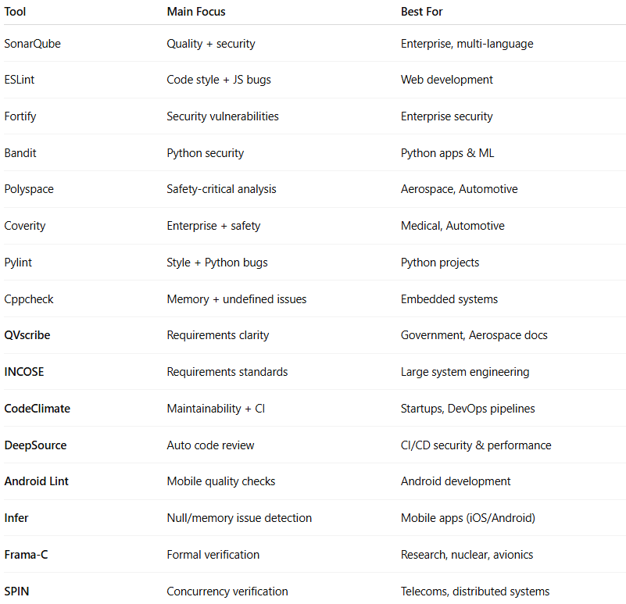
Tool | Main Focus | Best For
SonarQube | Quality + security | Enterprise, multi-language
ESLint | Code style + JS bugs | Web development
Fortify | Security vulnerabilities | Enterprise security
Bandit | Python security | Python apps & ML
Polyspace | Safety-critical analysis | Aerospace, Automotive
Coverity | Enterprise + safety | Medical, Automotive
Pylint | Style + Python bugs | Python projects
Cppcheck | Memory + undefined issues | Embedded systems
QVscribe | Requirements clarity | Government, Aerospace docs
INCOSE | Requirements standards | Large system engineering
CodeClimate | Maintainability + CI | Startups, DevOps pipelines
DeepSource | Auto code review | CI/CD security & performance
Android Lint | Mobile quality checks | Android development
Infer | Null/memory issue detection | Mobile apps (iOS/Android)
Frama-C | Formal verification | Research, nuclear, avionics
SPIN | Concurrency verification | Telecoms, distributed systems

✅ Summary:
# Source: AI Source: Provided by: [Data Path: Persons Table -> ID Column: 1, Name_En Column: Motasem Essam] -> From: [ChatGPT] on [8/23/2025]
Static Analysis Tools = automated checkers that analyze without execution, applying rules, standards, and best practices to ensure quality, security, and clarity.

Examples:

Code
# Source: AI Source: Provided by: [Data Path: Persons Table -> ID Column: 1, Name_En Column: Motasem Essam] -> From: [ChatGPT] on [8/23/2025]
- Detecting unused variables, unreachable code, or memory leaks.
- Finding security issues like SQL injection risks or buffer overflows.
- Ensuring compliance with coding standards (e.g., MISRA C for automotive software).
👉 Opposite of static analysis = Dynamic analysis, where the program is executed and observed (e.g., during testing).
Got it 👍 — let me walk you through several detailed examples of static analysis so you can see how it works in practice:

1. Detecting Unused Variables
# Source: AI Source: Provided by: [Data Path: Persons Table -> ID Column: 1, Name_En Column: Motasem Essam] -> From: [ChatGPT] on [8/23/2025]
Imagine this C code:
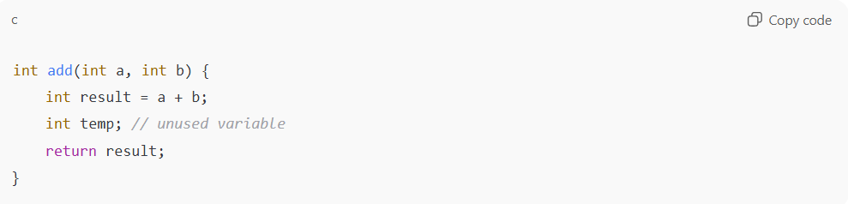
int add(int a, int b) {
int result = a + b;
int temp; // unused variable
return result;
}
- A static analysis tool scans the code.
- It detects that temp is declared but never used.
- This doesn’t cause a failure now, but it may indicate bad coding practice or unfinished logic.

2. Security Check – SQL Injection Risk
# Source: AI Source: Provided by: [Data Path: Persons Table -> ID Column: 1, Name_En Column: Motasem Essam] -> From: [ChatGPT] on [8/23/2025]
Python code:
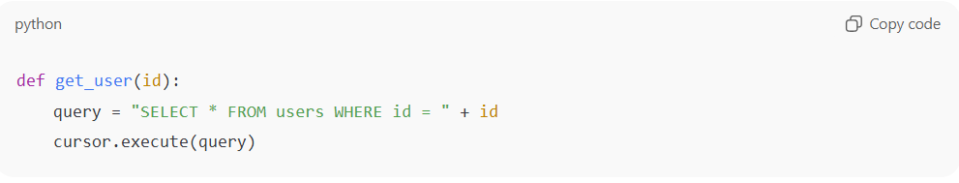
def get_user(id):
query = "SELECT * FROM users WHERE id = " + id
cursor.execute(query)
- A static analysis tool will flag this, because id is concatenated directly into the SQL query.
- If an attacker enters id = "1 OR 1=1", it can expose all records.
- The tool suggests using parameterized queries instead.

3. Buffer Overflow Detection
# Source: AI Source: Provided by: [Data Path: Persons Table -> ID Column: 1, Name_En Column: Motasem Essam] -> From: [ChatGPT] on [8/23/2025]
C code:
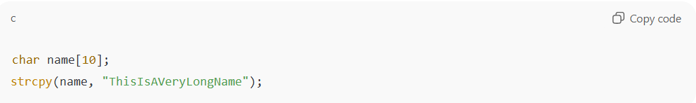
char name[10];
strcpy(name, "ThisIsAVeryLongName");
- Static analysis detects that "ThisIsAVeryLongName" is longer than the name array (10 characters).
- This would cause buffer overflow at runtime.
- The tool raises a high-severity warning, since this can crash the program or be exploited.

4. Dead Code / Unreachable Code
# Source: AI Source: Provided by: [Data Path: Persons Table -> ID Column: 1, Name_En Column: Motasem Essam] -> From: [ChatGPT] on [8/23/2025]
Java code:
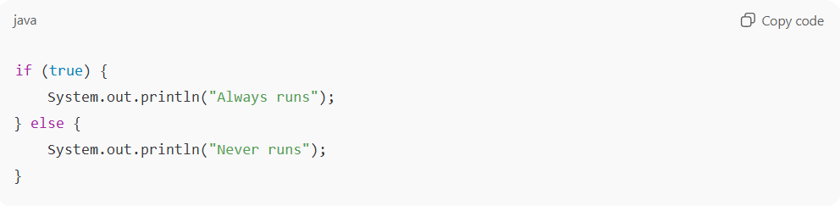
if (true) {
System.out.println("Always runs");
} else {
System.out.println("Never runs");
}
- The tool sees that the else branch is never reachable.
- It marks it as dead code, which bloats the program and may hide mistakes.

5. Coding Standard Violation (Style/Rules)
# Source: AI Source: Provided by: [Data Path: Persons Table -> ID Column: 1, Name_En Column: Motasem Essam] -> From: [ChatGPT] on [8/23/2025]
In safety-critical domains (like aviation or automotive), strict rules apply (e.g., MISRA-C).
Example:
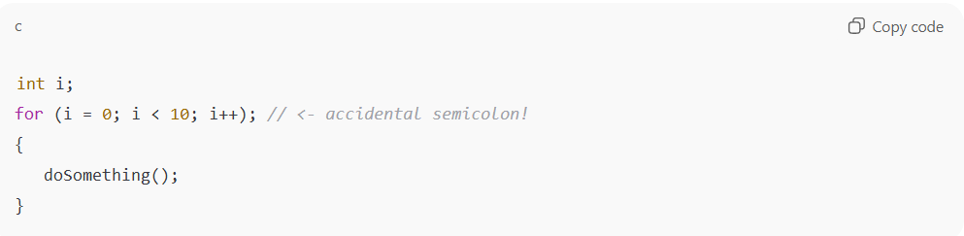
int i;
for (i = 0; i < 10; i++); // <- accidental semicolon!
{
doSomething();
}
- A static analyzer spots the empty loop (because of ;).
- doSomething() is not inside the loop as the programmer intended.
- Without the tool, this bug might slip into production.

Summary: Static analysis catches:
# Source: AI Source: Provided by: [Data Path: Persons Table -> ID Column: 1, Name_En Column: Motasem Essam] -> From: [ChatGPT] on [8/23/2025]
- Style issues (unused variables, naming conventions).
- Logical errors (unreachable code, empty loops).
- Security risks (SQL injection, buffer overflow).
- Compliance issues (safety standards).

Requirements Specification (Software Docs)
# Source: AI Source: Provided by: [Data Path: Persons Table -> ID Column: 1, Name_En Column: Motasem Essam] -> From: [ChatGPT] on [8/23/2025]
Great — let’s go deeper into Requirements Specification (Software Docs) examples and how static analysis can detect problems:

🔹 Example 1: Ambiguity
# Source: AI Source: Provided by: [Data Path: Persons Table -> ID Column: 1, Name_En Column: Motasem Essam] -> From: [ChatGPT] on [8/23/2025]
Requirement:
“The system should provide a fast response to user queries.”
Problem:
- Fast is ambiguous (does it mean 1 sec? 5 sec?).
Static Analysis Finding:
- Flags words like fast, user-friendly, efficient, adequate.
- Suggests measurable requirements, e.g.:
“The system shall return 95% of queries within 2 seconds.”

🔹 Example 2: Incompleteness
# Source: AI Source: Provided by: [Data Path: Persons Table -> ID Column: 1, Name_En Column: Motasem Essam] -> From: [ChatGPT] on [8/23/2025]
Requirement:
“The system shall support mobile devices.”
Problem:
- Which devices? iOS, Android, tablets? Minimum OS version?
Static Analysis Finding:
- Detects missing specifics.
- Suggests rewriting:
“The system shall support Android version 12 and later, and iOS 15 and later.”

🔹 Example 3: Inconsistency
# Source: AI Source: Provided by: [Data Path: Persons Table -> ID Column: 1, Name_En Column: Motasem Essam] -> From: [ChatGPT] on [8/23/2025]
Requirement A:
“Password shall be at least 8 characters long.”
Requirement B:
“Password shall be at least 10 characters long.”
Problem:
- Contradiction between requirements.
Static Analysis Finding:
- Detects conflict.
- Suggests clarification before design starts.

🔹 Example 4: Passive Voice / Unclear Responsibility
# Source: AI Source: Provided by: [Data Path: Persons Table -> ID Column: 1, Name_En Column: Motasem Essam] -> From: [ChatGPT] on [8/23/2025]
Requirement:
“Data shall be encrypted before being sent.”
Problem:
- Who is responsible? The application, the database, or the middleware?
Static Analysis Finding:
- Flags passive voice.
- Suggests rewriting:
“The client application shall encrypt all data before sending it to the server.”

🔹 Example 5: Unverifiable Requirement
# Source: AI Source: Provided by: [Data Path: Persons Table -> ID Column: 1, Name_En Column: Motasem Essam] -> From: [ChatGPT] on [8/23/2025]
Requirement:
“The software shall be user-friendly.”
Problem:
- User-friendly cannot be tested objectively.
Static Analysis Finding:
- Flags as unverifiable.
- Suggests measurable usability criteria, e.g.:
“80% of first-time users shall complete the onboarding process within 3 minutes without external help.”

✅ In short:
# Source: AI Source: Provided by: [Data Path: Persons Table -> ID Column: 1, Name_En Column: Motasem Essam] -> From: [ChatGPT] on [8/23/2025]
Static analysis on requirements specification helps detect:
- Ambiguity
- Incompleteness
- Inconsistency
- Unclear responsibility
- Non-verifiable requirements

Test Scripts
# Source: AI Source: Provided by: [Data Path: Persons Table -> ID Column: 1, Name_En Column: Motasem Essam] -> From: [ChatGPT] on [8/23/2025]
Perfect 👍 let’s go into Test Scripts examples and how static analysis can detect issues.
Test scripts are step-by-step instructions for testing software. Static analysis (without executing the tests) checks them for clarity, completeness, and consistency.

🔹 Example 1: Missing Expected Result
# Source: AI Source: Provided by: [Data Path: Persons Table -> ID Column: 1, Name_En Column: Motasem Essam] -> From: [ChatGPT] on [8/23/2025]
Test Script:
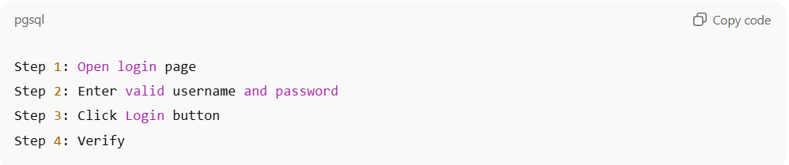
Step 1: Open login page
Step 2: Enter valid username and password
Step 3: Click Login button
Step 4: Verify
Problem:
- Step 4 says Verify but does not say what to verify.
Static Analysis Finding:
- Flags incomplete verification.
- Suggests:
“Verify that the user is redirected to the dashboard page.”

🔹 Example 2: Ambiguity in Action
# Source: AI Source: Provided by: [Data Path: Persons Table -> ID Column: 1, Name_En Column: Motasem Essam] -> From: [ChatGPT] on [8/23/2025]
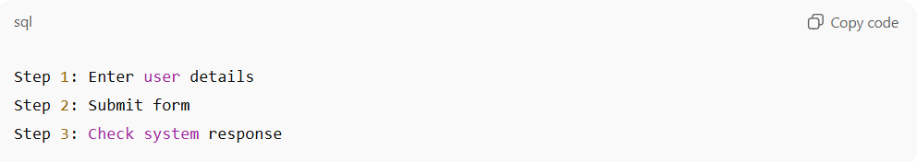
Test Script:
Step 1: Enter user details
Step 2: Submit form
Step 3: Check system response
Problem:
- Enter user details is vague → which fields? name, email, phone?
- Check system response is unclear → check success message? check database?
Static Analysis Finding:
- Flags vague wording.
- Suggests rewriting as:
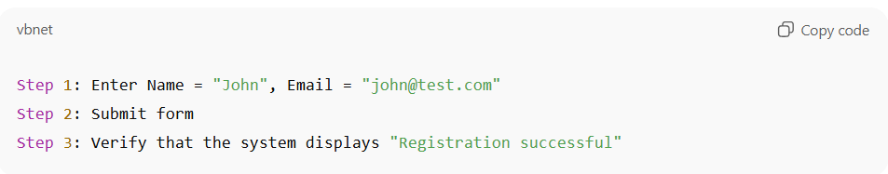
Step 1: Enter Name = "John", Email = "john@test.com"
Step 2: Submit form
Step 3: Verify that the system displays "Registration successful"

🔹 Example 3: Missing Preconditions
# Source: AI Source: Provided by: [Data Path: Persons Table -> ID Column: 1, Name_En Column: Motasem Essam] -> From: [ChatGPT] on [8/23/2025]
Test Script:
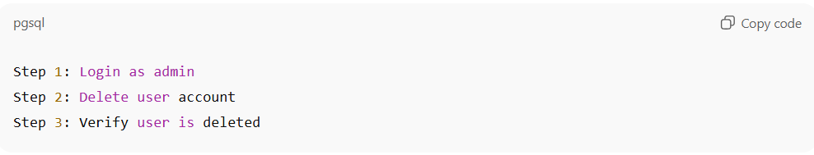
Step 1: Login as admin
Step 2: Delete user account
Step 3: Verify user is deleted
Problem:
- Preconditions not specified → Which user must exist to delete?
Static Analysis Finding:
- Suggests adding a precondition section:
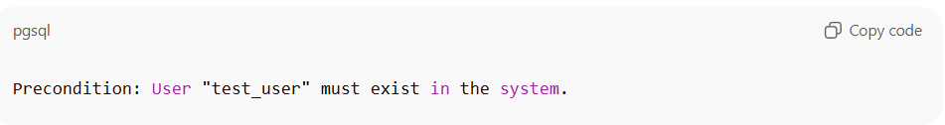
Precondition: User "test_user" must exist in the system.

🔹 Example 4: Inconsistent Terminology
# Source: AI Source: Provided by: [Data Path: Persons Table -> ID Column: 1, Name_En Column: Motasem Essam] -> From: [ChatGPT] on [8/23/2025]
Test Script A:
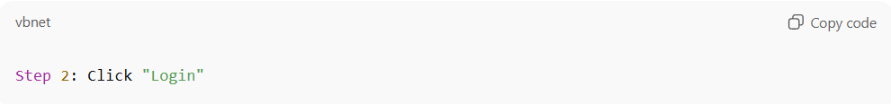
Step 2: Click "Login"
Test Script B:
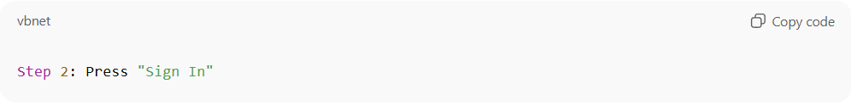
Step 2: Press "Sign In"
Problem:
- Both steps mean the same button, but with different names → leads to tester confusion.
Static Analysis Finding:
- Flags inconsistent terminology.
- Suggests unifying terminology with the UI specification.

🔹 Example 5: Non-Verifiable Step
# Source: AI Source: Provided by: [Data Path: Persons Table -> ID Column: 1, Name_En Column: Motasem Essam] -> From: [ChatGPT] on [8/23/2025]
Test Script:
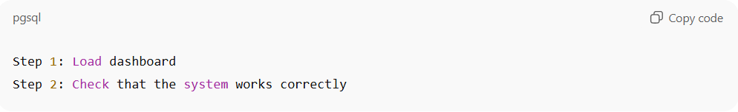
Step 1: Load dashboard
Step 2: Check that the system works correctly
Problem:
- Works correctly is not measurable.
Static Analysis Finding:
- Flags as unverifiable.
- Suggests defining objective checks, e.g.:
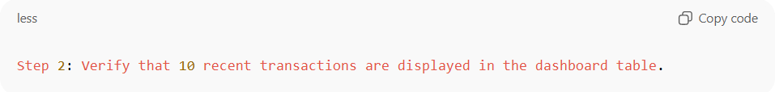
Step 2: Verify that 10 recent transactions are displayed in the dashboard table.

✅ Summary
# Source: AI Source: Provided by: [Data Path: Persons Table -> ID Column: 1, Name_En Column: Motasem Essam] -> From: [ChatGPT] on [8/23/2025]
Static analysis of test scripts catches:
- Missing expected results
- Ambiguity in actions
- Missing preconditions
- Inconsistent terminology
- Non-verifiable steps

API Documentation
# Source: AI Source: Provided by: [Data Path: Persons Table -> ID Column: 1, Name_En Column: Motasem Essam] -> From: [ChatGPT] on [8/23/2025]
Perfect 👍 let’s go through API Documentation examples and how static analysis can detect problems in them.
API docs describe how developers should use an API (methods, inputs, outputs, constraints). If they are unclear or inconsistent, developers may misuse the API → leading to failures.

🔹 Example 1: Missing Parameter Details
# Source: AI Source: Provided by: [Data Path: Persons Table -> ID Column: 1, Name_En Column: Motasem Essam] -> From: [ChatGPT] on [8/23/2025]
API Documentation:
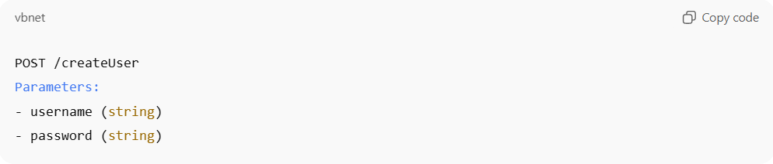
POST /createUser
Parameters:
- username (string)
- password (string)
Problem:
- No info about length limits, allowed characters, or password rules.
- Developer doesn’t know if password must be ≥ 8 chars, contain symbols, etc.
Static Analysis Finding:
- Flags parameters with missing constraints.
- Suggests rewriting:
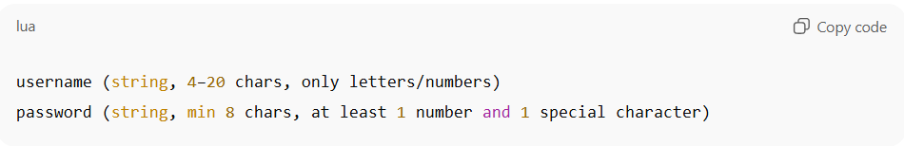
username (string, 4–20 chars, only letters/numbers)
password (string, min 8 chars, at least 1 number and 1 special character)

🔹 Example 2: Inconsistent Response Codes
# Source: AI Source: Provided by: [Data Path: Persons Table -> ID Column: 1, Name_En Column: Motasem Essam] -> From: [ChatGPT] on [8/23/2025]
API Documentation:
GET /user/{id}
Responses:
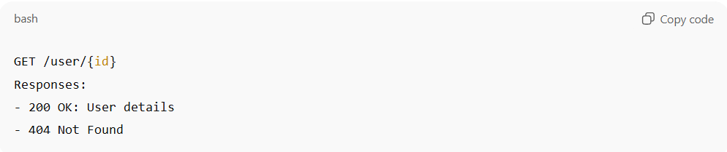
- 200 OK: User details
- 404 Not Found
Another API endpoint says:
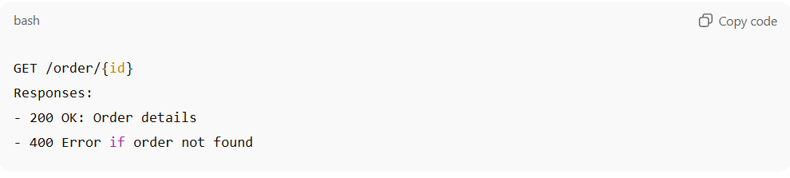
GET /order/{id}
Responses:
- 200 OK: Order details
- 400 Error if order not found
Problem:
- One endpoint uses 404 for not found, another uses 400.
- Inconsistency confuses developers.
Static Analysis Finding:
- Detects inconsistency in error codes.
- Suggests aligning all “not found” cases to 404 Not Found.

🔹 Example 3: Ambiguous Data Format
# Source: AI Source: Provided by: [Data Path: Persons Table -> ID Column: 1, Name_En Column: Motasem Essam] -> From: [ChatGPT] on [8/23/2025]
API Documentation:
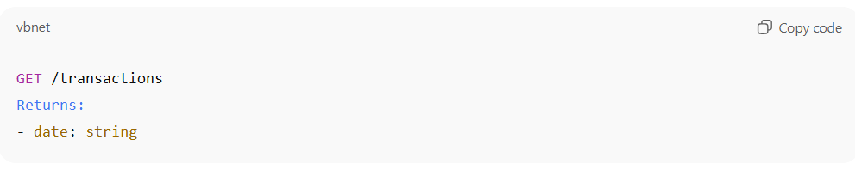
GET /transactions
Returns:
- date: string
Problem:
- “string” is ambiguous → is it YYYY-MM-DD? MM/DD/YYYY? with time zone?
Static Analysis Finding:
- Flags ambiguous data formats.
- Suggests rewriting:
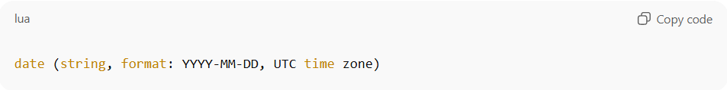
date (string, format: YYYY-MM-DD, UTC time zone)

🔹 Example 4: Missing Authentication Info
# Source: AI Source: Provided by: [Data Path: Persons Table -> ID Column: 1, Name_En Column: Motasem Essam] -> From: [ChatGPT] on [8/23/2025]
API Documentation:
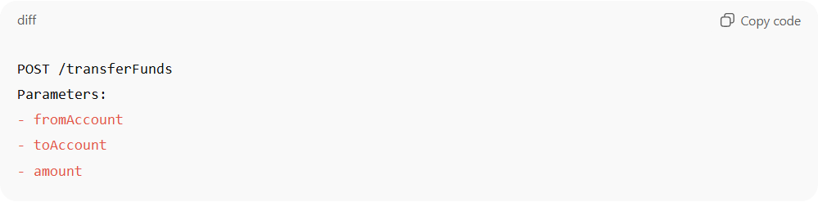
POST /transferFunds
Parameters:
- fromAccount
- toAccount
- amount
Problem:
- No mention of authentication or security (e.g., API keys, tokens).
- A developer might think it’s an open endpoint.
Static Analysis Finding:
- Flags sensitive operations with no authentication rules documented.
- Suggests rewriting:
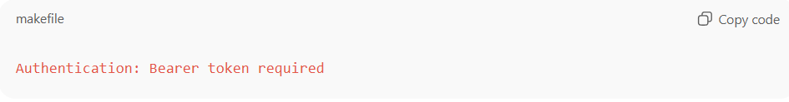
Authentication: Bearer token required

🔹 Example 5: Unverifiable Requirement in Docs
# Source: AI Source: Provided by: [Data Path: Persons Table -> ID Column: 1, Name_En Column: Motasem Essam] -> From: [ChatGPT] on [8/23/2025]
API Documentation:
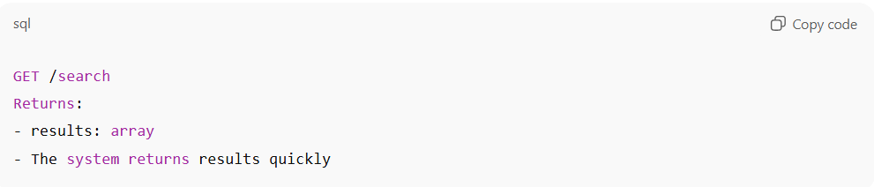
GET /search
Returns:
- results: array
- The system returns results quickly
Problem:
- quickly is vague and non-testable.
Static Analysis Finding:
- Flags unverifiable terms.
- Suggests measurable wording:
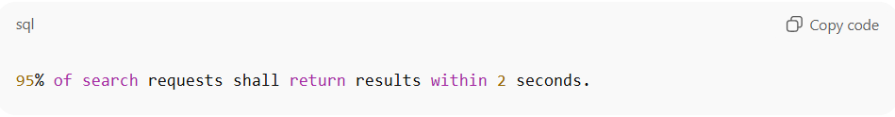
95% of search requests shall return results within 2 seconds.

✅ Summary:
# Source: AI Source: Provided by: [Data Path: Persons Table -> ID Column: 1, Name_En Column: Motasem Essam] -> From: [ChatGPT] on [8/23/2025]
Static analysis of API documentation catches:
- Missing parameter constraints
- Inconsistent response codes
- Ambiguous data formats
- Missing authentication/security details
- Unverifiable/vague requirements

Coding Standards Documentation
# Source: AI Source: Provided by: [Data Path: Persons Table -> ID Column: 1, Name_En Column: Motasem Essam] -> From: [ChatGPT] on [8/23/2025]
Great 👍 let’s look at Coding Standards Documentation examples and how static analysis can be applied.
Coding standards are written rules a team or industry defines (for readability, safety, or security). Static analysis tools can automatically check if the source code follows those documented rules.

🔹 Example 1: Naming Conventions
# Source: AI Source: Provided by: [Data Path: Persons Table -> ID Column: 1, Name_En Column: Motasem Essam] -> From: [ChatGPT] on [8/23/2025]
Coding Standards Doc:
- All class names must use PascalCase.
- All variables must use camelCase.
Code:
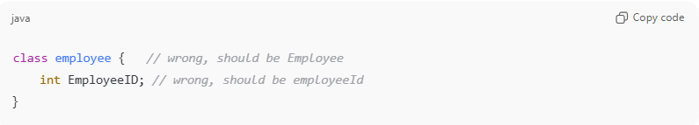
class employee { // wrong, should be Employee
int EmployeeID; // wrong, should be employeeId
}
Static Analysis Finding:
- Flags naming violations.
- Suggests corrections based on documented rules.

🔹 Example 2: Commenting Rules
# Source: AI Source: Provided by: [Data Path: Persons Table -> ID Column: 1, Name_En Column: Motasem Essam] -> From: [ChatGPT] on [8/23/2025]
Coding Standards Doc:
- Every function must have a docstring explaining inputs, outputs, and purpose.
Code:
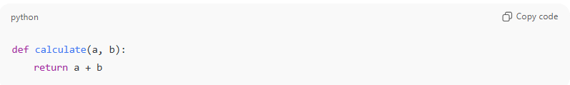
def calculate(a, b):
return a + b
Static Analysis Finding:
- Flags missing documentation.
- Suggests adding:
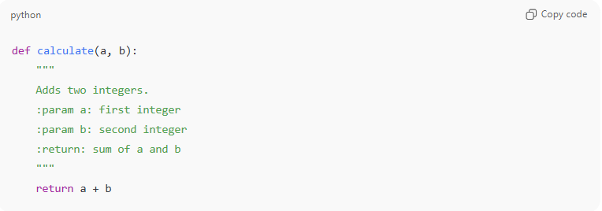
def calculate(a, b):
"""
Adds two integers.
:param a: first integer
:param b: second integer
:return: sum of a and b
"""
return a + b

🔹 Example 3: Braces and Indentation Style
# Source: AI Source: Provided by: [Data Path: Persons Table -> ID Column: 1, Name_En Column: Motasem Essam] -> From: [ChatGPT] on [8/23/2025]
Coding Standards Doc:
- In C, opening brace { must be on a new line.
Code:
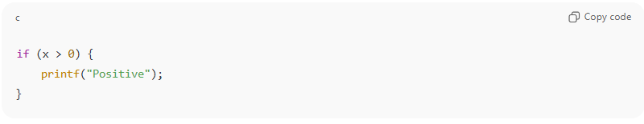
if (x > 0) {
printf("Positive");
}
Static Analysis Finding:
- Flags brace style violation.
- Suggests:
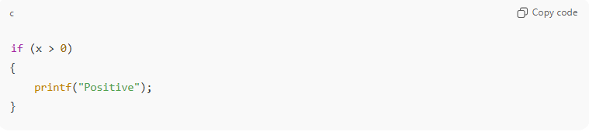
if (x > 0)
{
printf("Positive");
}

🔹 Example 4: Error Handling Rules
# Source: AI Source: Provided by: [Data Path: Persons Table -> ID Column: 1, Name_En Column: Motasem Essam] -> From: [ChatGPT] on [8/23/2025]
Coding Standards Doc:
- All database calls must handle exceptions.
Code:
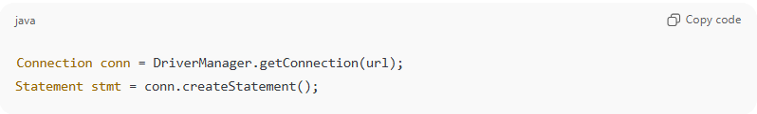
Connection conn = DriverManager.getConnection(url);
Statement stmt = conn.createStatement();
Static Analysis Finding:
- Flags missing try-catch.
- Suggests adding exception handling.

🔹 Example 5: Security Rules (MISRA-C or CERT Standards)
# Source: AI Source: Provided by: [Data Path: Persons Table -> ID Column: 1, Name_En Column: Motasem Essam] -> From: [ChatGPT] on [8/23/2025]
Coding Standards Doc:
- Never use gets() in C (unsafe, causes buffer overflows).
Code:
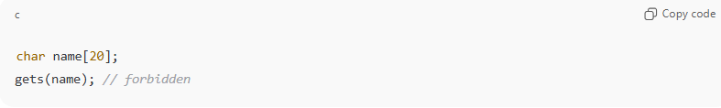
char name[20];
gets(name); // forbidden
Static Analysis Finding:
- Flags rule violation.
- Suggests using fgets() instead.

✅ Summary:
# Source: AI Source: Provided by: [Data Path: Persons Table -> ID Column: 1, Name_En Column: Motasem Essam] -> From: [ChatGPT] on [8/23/2025]
Static analysis against coding standards detects:
- Naming convention violations
- Missing documentation/comments
- Wrong indentation or brace style
- Missing error handling
- Unsafe function usage

Summary
# Source: AI Source: Provided by: [Data Path: Persons Table -> ID Column: 1, Name_En Column: Motasem Essam] -> From: [ChatGPT] on [8/23/2025]
🔹 Static Analysis for Documentation (recap)
- Ambiguity → Vague words (fast, efficient, user-friendly).
- Inconsistency → Requirement ≠ Design doc.
- Incompleteness → Missing steps/results in test cases.
- Non-compliance → Docs don’t match coding standards.

🔹 Static Analysis for Code
Here’s what it typically detects (without running the program):
- Syntax Errors & Violations
  - Example: Missing semicolon (;), undeclared variable.
  - Tool: ESLint, Pylint.
- Code Style & Standards Compliance
  - Example: Variable naming doesn’t follow convention, indentation errors.
  - Tool: Pylint, StyleCop, ESLint.
- Unused / Dead Code
  - Example: A function is defined but never called.
  - Tool: SonarQube, CodeClimate.
- Type & Data Issues
  - Example: Assigning a string to an integer variable in statically typed languages.
  - Tool: MyPy (Python), TypeScript compiler.
- Security Vulnerabilities
  - Example: SQL injection risk if query built with string concatenation.
  - Tool: Fortify, Bandit.
- Concurrency Issues
  - Example: Race conditions, deadlocks in multi-threaded code.
  - Tool: Coverity, SPIN.
- Memory & Resource Leaks
  - Example: Forgetting to free allocated memory (malloc in C).
  - Tool: Cppcheck, Polyspace.
- Code Complexity & Maintainability
  - Example: Function too long (hundreds of lines), hard to maintain.
  - Tool: SonarQube, CodeClimate.
- Standards & Compliance Checking
  - Example: MISRA-C compliance in automotive software.
  - Tool: Polyspace, LDRA.

✅ Quick Contrast
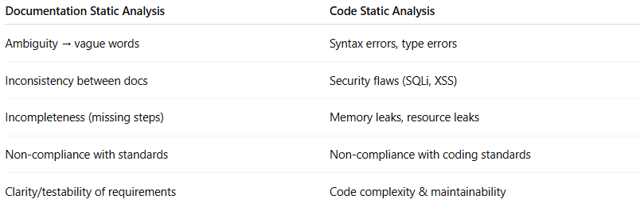
Documentation Static Analysis | Code Static Analysis
Ambiguity → vague words | Syntax errors, type errors
Inconsistency between docs | Security flaws (SQLi, XSS)
Incompleteness (missing steps) | Memory leaks, resource leaks
Non-compliance with standards | Non-compliance with coding standards
Clarity/testability of requirements | Code complexity & maintainability

